Html parts for click button

<button onclick="myFunction()">Show charts</button>

<div class="hidden" id="chartimg">

<img src="images/eggs_hatched_released.png" alt="data chart" width="800" height="400">

</div>

****** make sure you put this inside img div tag

it would look some what like this

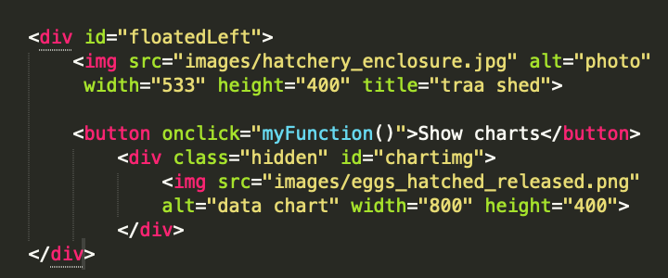

// this is the function of the Javascript for click button to reveal image

// also mind that its calling the div

function myFunction() {

var e = document.getElementById("chartimg");

if(e.style.display == 'block') {

e.style.display = 'none';

} else {

e.style.display = 'block';

}

}

